**AIR QUALITY MONITORING DEVICE**

**Submitted in partial fulfillment of the requirements for the degree of B.Tech. in Electrical and Electronics Engineering.**

**By:**

**UTKARSH GAUR (1302721107)**

**VIKAS GUPTA (1302721113)**

**PRAVEEN KUMAR YADAV (1302721067)**

**Under the supervision of**

**Asst. Prof. Deepak Narang**

**Department Of Electrical and Electronics Engineering**



**Ajay Kumar Garg Engineering College, Ghaziabad**

**27th Km Stone, Delhi-Hapur Bypass Road, Adhyatmik Nagar, Ghaziabad-201009**

**APJ A.K. Technical University, Lucknow**

**May 2017**

**DECLARATION**

We hereby declare that this submission is our own work and that, to the best of our knowledge and belief, it contains no material previously published or written by another person, nor material which to a substantial extent has been accepted for the award of any other degree or diploma by the university or other institute of higher learning, except where due acknowledgement has been made in the text.

Signature: Signature:

UTKARSH GAUR  VIKAS GUPTA

Roll No: 130721107 Roll No: 1302721113

Signature:

PRAVEEN KUMAR YADAV

Roll No: 1302721067

**CERTIFICATE**

This is to certify that Project Report entitled “**AIR QUALITY MONITORING DEVICE”** which is submitted by Utkarsh gaur, Vikas gupta and Praveen kumar yadav in the partial fulfillment of requirement for the award of degree of Bachelor of Technology (Electrical and Electronics Engineering) submitted to Dr. A.P.J. Abdul Kalam Technical University, Lucknow is a record of student’s own work carried out under my supervision. The matter in this report has not been submitted to any University or Institution for award of any degree.

**Supervisor:**

Asst. Prof. Deepak Narang

EN Department

**HoD:**

Dr. Bhupal Singh

Date:

**ACKNOWLEDGEMENTS**

We take this opportunity to express our deep sense of gratitude and regard to

**Mr. Deepak Narang**, Asst. Prof. (EN Deptt.), Ajay Kumar Garg Engineering College, Ghaziabad for his continuous encouragement and able guidance, we needed to complete this project.

We would pay our sincere gratitude to the Head of the Deptt. (EN), **Dr. Bhupal Singh** for his precious and enlightening words of wisdom which motivated us throughout our project work.

**ABSTRACT**

Air pollution and concern about air quality is not something new. Complaints were recorded even in the 13th century when coal was first used for industrial purposes in London. From the middle of the 19th century, the atmosphere of major British cities was regularly polluted by coal smoke in winters, giving rise to the infamous mixture of fog and smoke known as smog. Today the emphasis has shifted from pollution problems caused by the industry to the ones associated with motor vehicle emissions.

In this project the sensors used are BMP180 (pressure sensor), MQ-135(gas sensor), DHT11(temperature and humidity sensor) and DS1307(real time clock) .Here we present a meter for monitoring air pressure, gas concentration, temperature, humidity, date and time, which Design a tool which will-

1) Sense quality of air and display it in the form of percentage.

2) Sense the presence of benzene, alcohol and smoke(Carbon Mono-oxide) in air and display on LCD.

3) Sense the temperature & humidity and display it on LCD.

4) Sense the pressure of air and display on LCD.

**TABLE OF CONTENTS**

Declaration ii

Certificate iii

Acknowledgements iv

Abstract v

Table of contents vi

**Chapter 1. Introduction 1-2**

1.1 Air Quality Index 1

1.2 Project idea 2

1.3 Objective 2

**Chapter 2. Working of the project 3-8**

2.1 Working Principle 3

2.2 Block diagram of project 4

2.3 Circuit diagram of project 7

2.4 Component required 8

**Chapter 3. Hardware Specifications 9-23**

3.1 ATMEGA328P Arduino UNO 9

3.2 Temp & humidity sensor (DHT11) 12

3.3 Real time clock (DS1302)

3.4 Gas sensor(MQ135) 16

3.5 Pressure sensor(BMP180) 18

3.6 LCD(20x4) 20

3.7 RFID Reader 23

**Chapter 4. Software Specifications 25-56**

4.1Program 25

C**hapter 5. Results 56**

5.1 Final Display And Conclusions 56

**Chapter 6. Future Scope 58**

**References 59-60**

**INTRODUCTION**

**AIR QUALITY INDEX:**

Air Quality Index, or AQI, is a number used by government agencies to communicate to the public how polluted the air currently is, or how polluted it is likely to become. As AQI increases, an increasingly large percentage of the population experiences severe adverse health effects. Different countries have their own air-quality indices corresponding to different national air-quality standards. Some of these are Air Quality Health Index (Canada), Air Pollution Index (Malaysia) and Pollutant Standards Index (Singapore).

The national AQI was launched in New Delhi on September 17, 2014, under Swachh Bharat Abhiyan. There are six AQI categories (Table I) of the same. The proposed AQI considers eight pollutants (PM10, PM2.5, NO2, SO2, CO, O3, NH3 and Pb) for which short-term (up to 24-hour averaging period) National Ambient Air Quality Standards are prescribed.

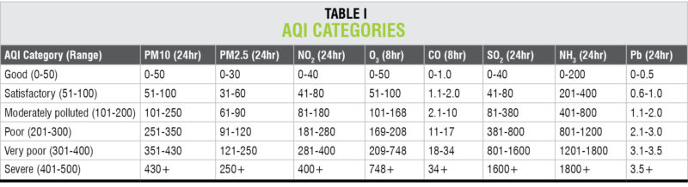

**PROJECT IDEA:**

In this project the sensors used are BMP180 (pressure sensor), MQ-135(gas sensor), DHT11(temperature and humidity sensor) and DS1307(real time clock) .Here we present a meter for monitoring air pressure, gas concentration, temperature, humidity,date and time, which costs around Rs3000 only. A typical diagram of the air-quality monitoring device is shown in Fig.1

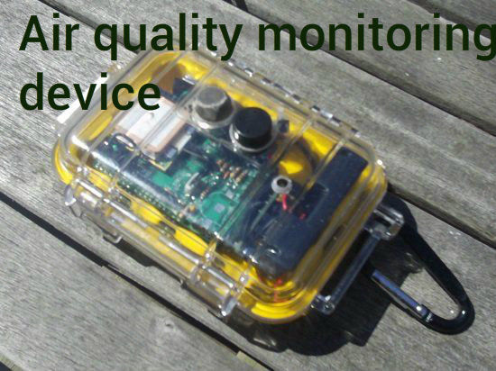

**OBJECTIVE:**

* To create a tool which will monitor the quality of air of our environment.
* Sense the content of different gases present in air or area around us.(MQ-135)
* Sense the temperature, humidity (DHT-11) and pressure (BMP180)of air.
* Keep the date and time (real time clock).
* Display the data on LCD (16x2).

**WORKING OF PROJECT**

**WORKING PRINCIPLE:**

* Project’s basic principle of working is the sensing of data from the sensor .
* Convert the analog (voltage) data into digital form.
* Process the proportional digital data and display it on LCD.
* Gas sensor directly display the digital data (HIGH /LOW)

**BLOCK DIAGRAM:**

In this project the sensors used are BMP180 (pressure sensor), MQ-135(gas sensor), DHT11(temperature and humidity sensor) and DS1307(real time clock) .Here we present a meter for monitoring air pressure, gas concentration, temperature, humidity, date and time, display data on LCD. A Block diagram of the air-quality monitoring device is shown in Fig.

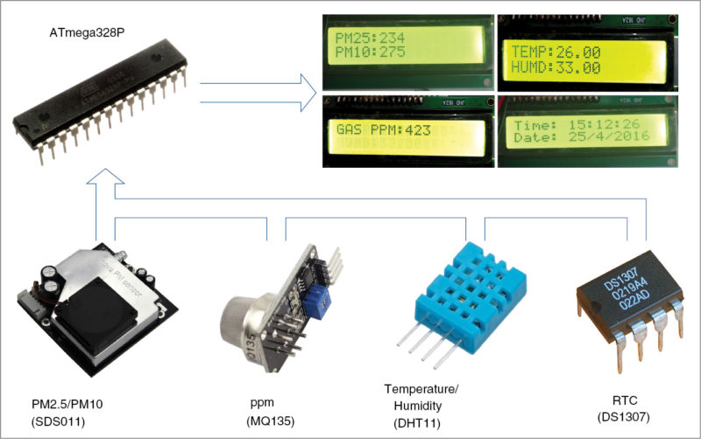

**CIRCUIT AND WORKING:**

Circuit diagram of the air-quality meter is shown in Fig. 2. Heart of the circuit is ATmega328P. Other components used are voltage regulators 7805 (IC1 and IC2), 16×2 LCD display, temperature and humidity sensor (DHT11), gas sensor (MQ135) and Pressure sensor.

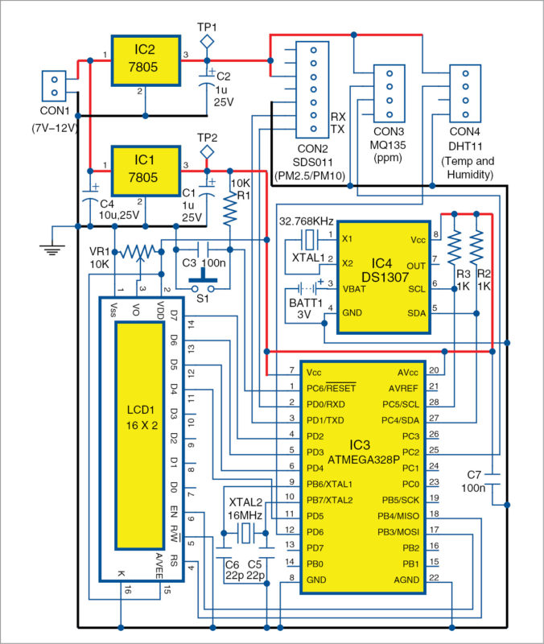

**COMPONENTS REQUIRED:**

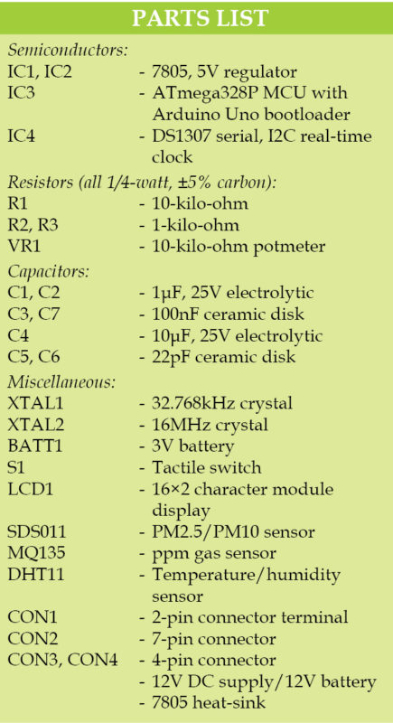

**PCB LAYOUT OF PROJECT:**

An actual-size, single-side PCB for the air-quality meter is shown in Fig. and its component layout in Fig. Suitable connectors are provided on the PCB for input and output.

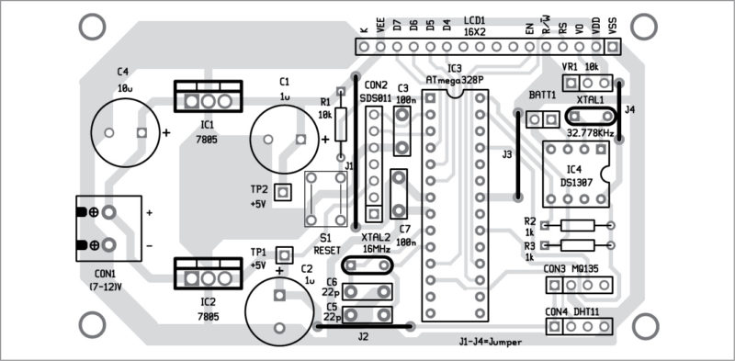

**HARDWARE DESCRIPTION:**

**ATMEGA328P:** It can be programmed with embedded software using a standard programmer or Arduino IDE. ATmega328P offers 23 input/output functional ports, and a 16MHz crystal oscillator is used to provide timing/clock reference. The Atmel® Pico Power® ATmega328/P is a low-power CMOS 8-bit microcontroller based on the AVR® enhanced RISC architecture. By executing powerful instructions in a single clock cycle, the ATmega328/P achieves throughputs close to 1MIPS per MHz .This empowers system Feature.

**FEATURES:**

High Performance, Low Power Atmel®AVR® 8-Bit Microcontroller Family.

• Advanced RISC Architecture

– 131 Powerful Instructions

– Most Single Clock Cycle Execution

– 32 x 8 General Purpose Working Registers

– Fully Static Operation

– Up to 20 MIPS Throughput at 20MHz

– On-chip 2-cycle Multiplier

• High Endurance Non-volatile Memory Segments

– 32KBytes of In-System Self-Programmable Flash program Memory

– 1KBytes EEPROM – 2KBytes Internal SRAM

– Write/Erase Cycles: 10,000 Flash/100,000 EEPROM

– Data Retention: 20 years at 85°C/100 years at 25°C(1)

– Optional Boot Code Section with Independent Lock Bits

• In-System Programming by On-chip Boot Program

• True Read-While-Write Operation

– Programming Lock for Software Security

• Atmel® Q-Touch® Library Support

– Capacitive Touch Buttons, Sliders and Wheels

– Q-Touch and Q-Matrix® Acquisition

– Up to 64 sense channels designer to optimize the device for power consumption versus processing speed.

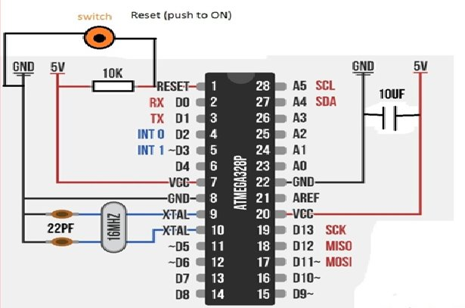

**PIN DIAGRAM:**

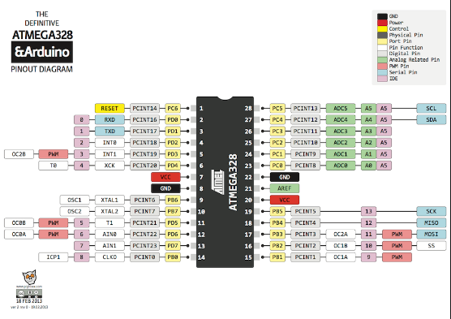 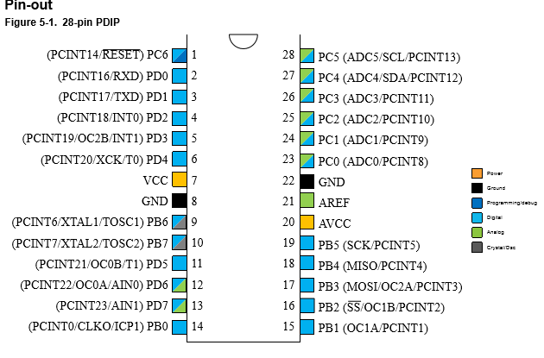

**TEMPERATURE AND HUMIDITY MODULE (DHT11):**

This composite sensor contains a calibrated digital signal output of temperature and humidity. The sensor (connected to CON4) includes a resistive-type humidity measurement component and an NTC temperature-measurement device. Its output pin is connected to pin 12 of ATMEGA328P. This DHT11 Temperature & Humidity Sensor features a temperature & humidity sensor complex with a calibrated digital signal output. By using the exclusive digital-signal-acquisition technique and temperature & humidity sensing technology, it ensures high reliability and excellent long-term stability. This sensor includes a resistive-type humidity measurement component and an NTC temperature measurement component, and connects to a high-performance 8-bit microcontroller, offering excellent quality, fast response, anti-interference ability and cost-effectiveness.

Each DHT11 element is strictly calibrated in the laboratory that is extremely accurate on humidity calibration. The calibration coefficients are stored as programmes in the OTP memory, which are used by the sensor’s internal signal detecting process. The single-wire serial interface makes system integration quick and easy. Its small size, low power consumption and up-to-20 meter signal transmission making it the best choice for various applications, including those most demanding ones. The component is 4-pin single row pin package. It is convenient to connect and special packages can be provided according to users’ request.

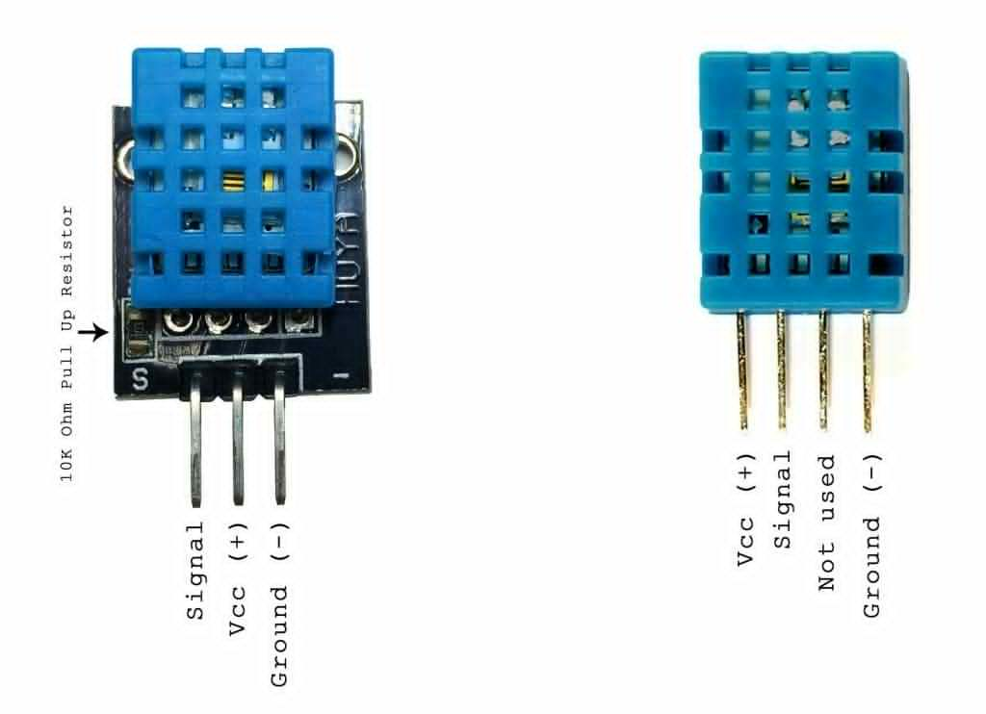

**CONNECTION OF DHT-11 WITH ATMEGA328P:**

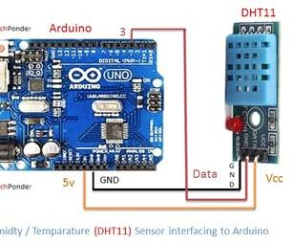

**ELECTRICAL CHARACTERICS:**

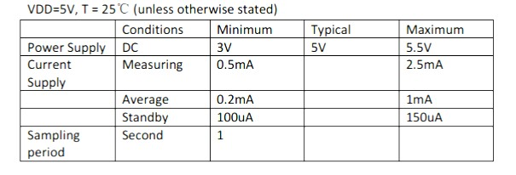

**SERIAL REAL-TIME CLOCK (RTC) IC (DS1302):**

 It is a low-power, full binary-coded decimal (BCD) clock/calendar with 56 bytes of NV SRAM. Addresses and data are transferred serially through an I2C, bi-directional bus. The clock/calendar provides information about seconds, minutes, hours, days, dates, months and years. SCL and SDA pins of IC4 are connected to SCL (pin 28) and SDA (pin 27) pins of ATmega328P, respectively.

The DS1302 trickle-charge timekeeping chip contains a real-time clock/calendar and 31 bytes of static RAM. It communicates with a microprocessor via a simple serial interface. The real-time clock/calendar provides seconds, minutes, hours, day, date, month, and year information. The end of the month date is automatically adjusted for months with fewer than 31 days, including corrections for leap year. The clock operates in either the 24-hour or 12-hour format with an AM/PM indicator.

Interfacing the DS1302 with a microprocessor is simplified by using synchronous serial communication. Only three wires are required to communicate with the clock/RAM: CE, I/O (data line), and SCLK (serial clock). Data can be transferred to and from the clock/RAM 1 byte at a time or in a burst of up to 31 bytes. The DS1302 is designed to operate on very low power and retain data and clock information on less than 1µW.

The DS1302 is the successor to the DS1202. In addition to the basic timekeeping functions of the DS1202, the DS1302 has the additional features of dual power pins for primary and backup power supplies, programmable trickle charger for VCC1, and seven additional bytes of scratchpad memory.

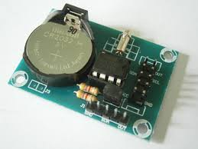 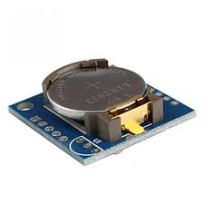

**Top view of real time clock(DS1302)**

**BLOCK DIAGRAM:**

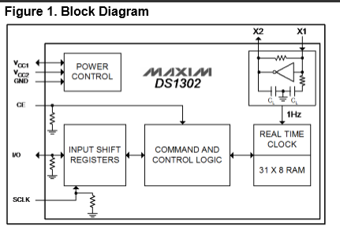

**Connection of RTC with ATMEGA328P:**

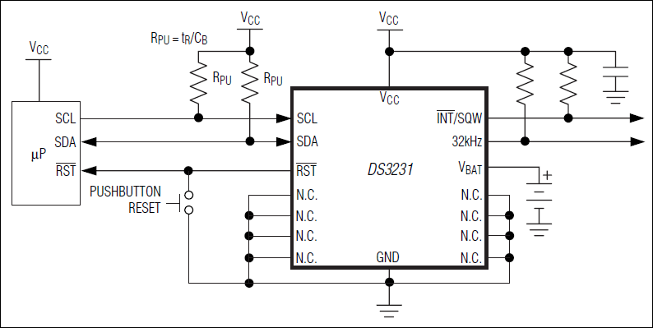

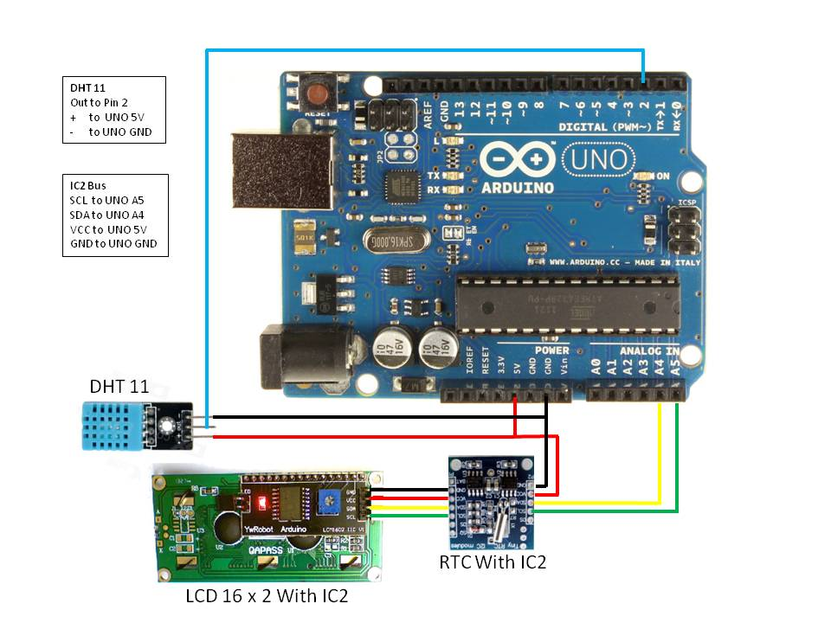

**GAS SENSOR (MQ135)**

 The sensitive material of the sensor is tin-dioxide (SnO2), whose conductivity increases with concentration of gas. Change in conductivity is converted into output voltage signal, which varies corresponding to the concentration of the combustible gas. MQ135 is highly sensitive to ammonia, sulphide and benzene steam, smoke and other harmful gases. It is a low-cost sensor, suitable for different applications. Output of the gas sensor (CON3) is connected to analogue input pin 25 of Iatmega328p. Sensitive material of MQ135 gas sensor is SnO2, which with lower conductivity in clean air. When thetarget combustible gas exist, The sensor’s conductivity is more higher along with the gas concentrationrising. Please use simple electrocircuit, Convert change of conductivity to correspond output signal of gas concentration.MQ135 gas sensor has high sensitity to Ammonia, Sulfide and Benze steam, also sensitive to smoke and other harmful gases. It is with low cost and suitable for different application.



**Character Configuration:**

* Good sensitivity to Harmful gases in wide range

* High sensitivity to Ammonia, Sulfide and Benze

* Long life and low cost

* Simple drive circuit

**CONNECTION OF MQ-135 WITH ATMEGA328P:**

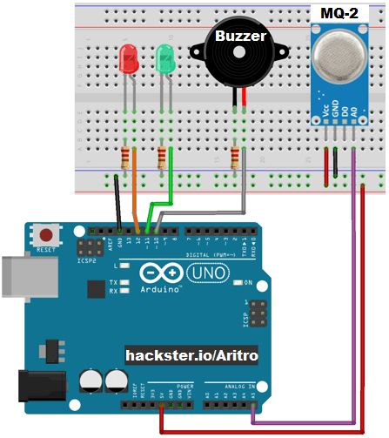

**WORKING OF MQ-135:**

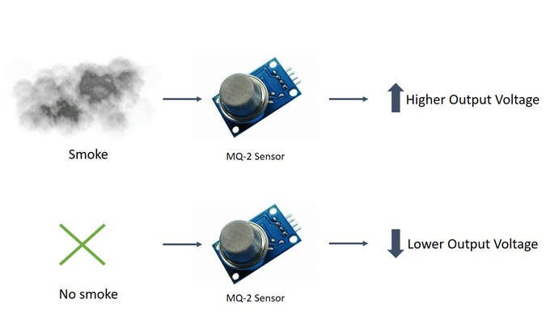

**PRESSURE SENSOR (BMP180)**

This precision sensor from Bosch is the best low-cost sensing solution for measuring barometric pressure and temperature. Because pressure changes with altitude you can also use it as an altimeter! The sensor is soldered onto a PCB with a 3.3V regulator, I2C level shifter and pull-up resistors on the I2C pins.  
  
The BMP180 is the next-generation of sensors from Bosch, and replaces the BMP085. The good news is that it **is completely identical to the BMP085 in terms of firmware/software** - you can use our BMP085 tutorial and any example code/libraries as a drop-in replacement. The XCLR pin is not physically present on the BMP180 so if you need to know that data is ready you will need to query the I2C bus.  
This board is 5V compliant - a 3.3V regulator and a i2c level shifter circuit is included so you can use this sensor safely with 5V logic and power.  
Using the sensor is easy. For example, if you're using an Arduino, simply connect the VIN pin to the 5V voltage pin, GND to ground, SCL to I2C Clock (Analog 5) and SDA to I2C Data (Analog4).

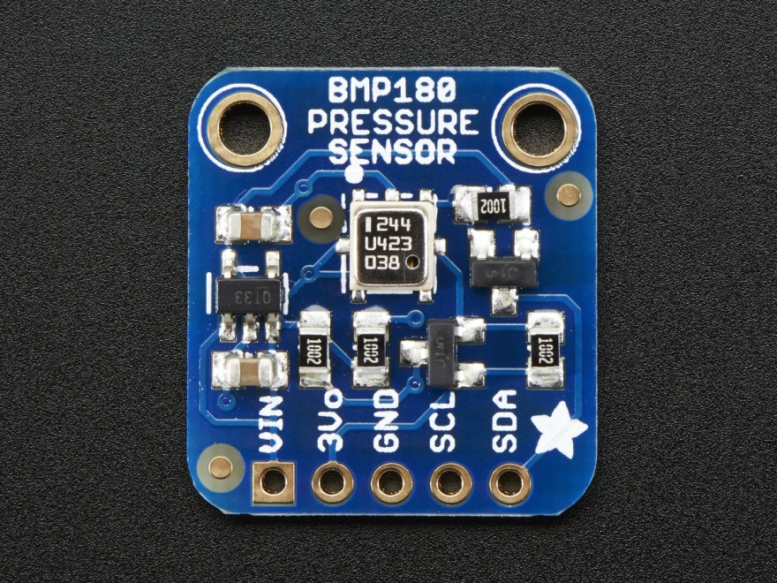

**TECHNICAL DETAILS:**

* Vin: 3 to 5VDC
* Logic: 3 to 5V compliant
* Pressure sensing range: 300-1100 hPa (9000m to -500m above sea level)
* Up to 0.03hPa / 0.25m resolution
* -40 to +85°C operational range, +-2°C temperature accuracy
* This board/chip uses I2C 7-bit address 0x77.

**CONNECTIONS OF BMP180 WITH ATMEGA328P:**

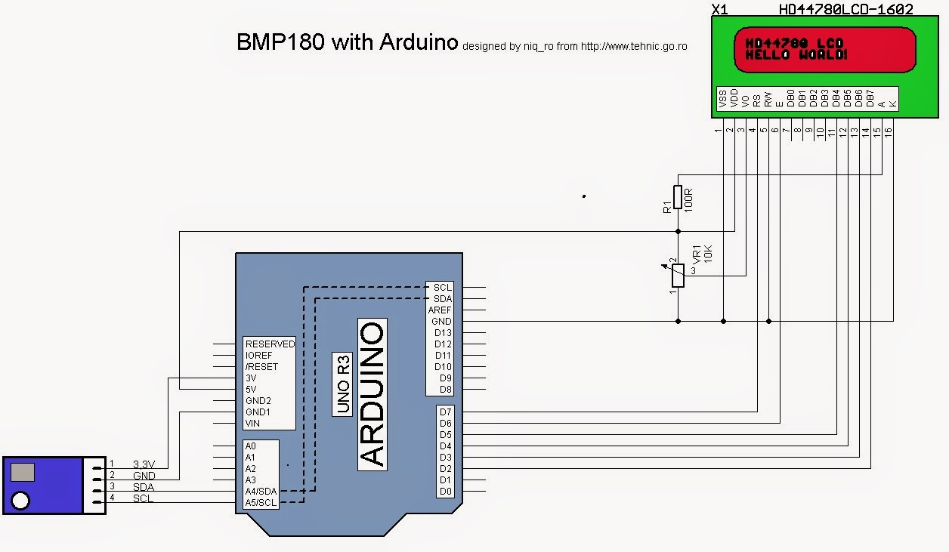

**LCD 20x4**

**DESCRIPTION:** This is a basic 20 character by 4 line display. Utilizes the extremely common HD44780 parallel interface chipset .Interface code is freely available. You will need ~11 general I/O pins to interface to this LCD screen. Includes LED backlight.

**FEATURES**

• Type: Character

• Display format: 20 x 4 characters

• Built-in controller: ST 7066 (or equivalent)

• Duty cycle: 1/16

• 5 x 8 dots includes cursor

• + 5 V power supply (also available for + 3 V)

• LED can be driven by pin 1, pin 2, pin 15, pin 16 or A and K

• N.V. optional for + 3 V power supply

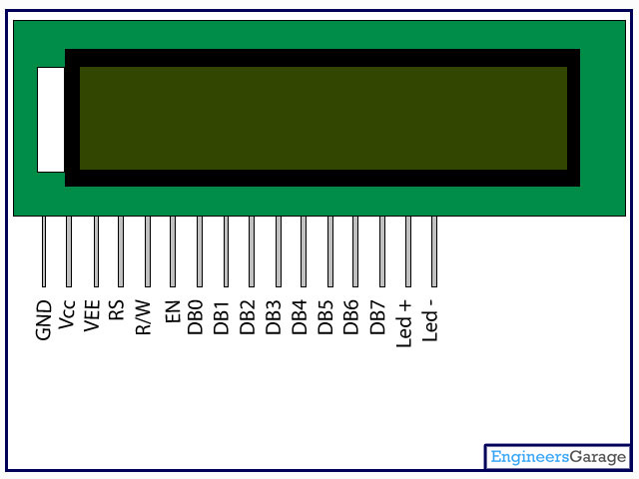

**PIN CONFIGURATION OF LCD**

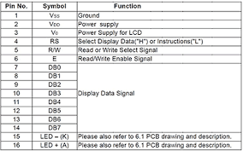

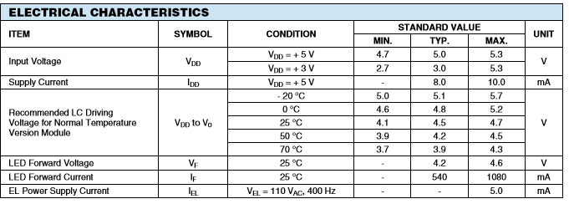

**Software**

Board menu in Arduino IDE and burn the program (sketch) through the standard USB port in the computer.→The software is written in Arduino programming language. ATmega328P is programmed using Arduino IDE software. ATmega328P comes with a boot loader that allows to upload a new code to it without the use of an external hardware programmer. Select the correct board from Tools

Various operations are implemented in the code as follows:  
RTC library is easy to use and can get the date, time and day of the week accurately.

DHT.temperature and DHT.humidity read temperature and humidity, respectively.

PM_CAL() function calibrates PM2.5/PM10 value.